**Saint Brigid Saint John the Baptist**

The Most Holy

Trinity Sunday

May 27, 2018

**Catholic Church Catholic Church**

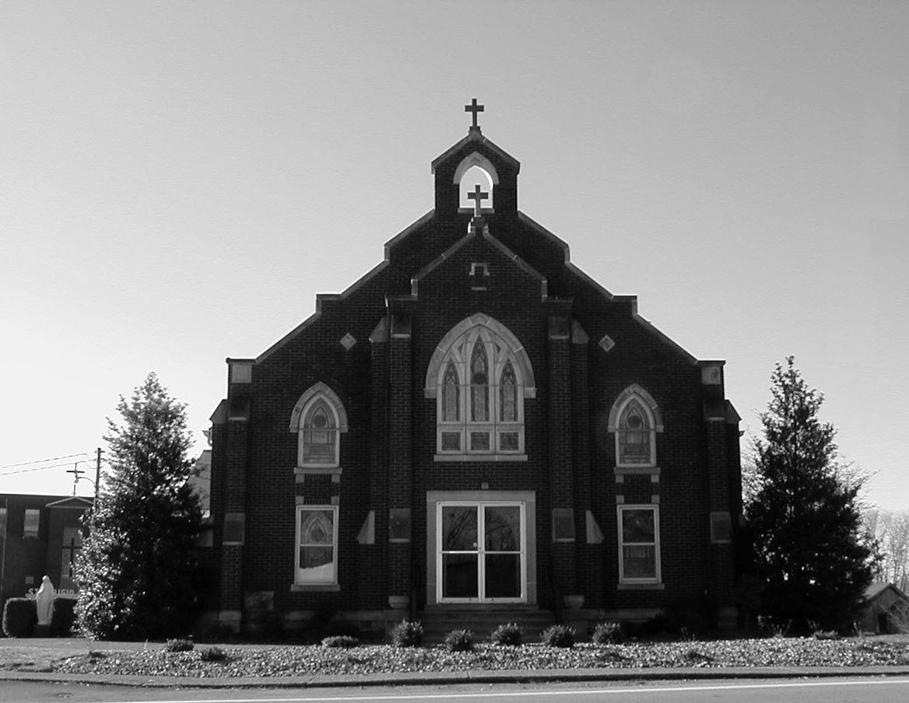

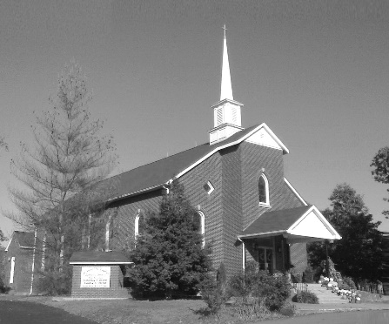

**Pastor:**

***Rev. Daniel L. Lincoln***

Rectory: (270) 877-2546

**Deacon:**

***Michael A. Ryan***

(270) 272-6789

314 E. Main St. 657 St. John Church Rd.

Vine Grove, KY 40175 Elizabethtown, KY 42701

Clustered Parish Office: Clustered Parish Office:

(270) 877-2461 (270) 877-2461

**ANNOINTING OF THE SICK:**

Notify the parish office when a family member is hospitalized.

**BAPTISM:**

Contact the parish office for information about the required preparation class.

**BULLETIN:**

Information must be submitted in writing by note or email to the parish office **no later than 12:00 noon on Wednesdays** for the following weekend. When sending an email, please put “BULLETIN,” and the name of the parish the announcement is for, in the subject line.

**MARRIAGE:**

Contact Father at least 6 months prior to the wedding date to complete required marriage preparations and to schedule the date.

**RCIA (Rite of Christian Initiation of Adults):**

Contact the Worship Chairperson for information.

**DEW MEMORIAL LIBRARY:**

(in St. Brigid Church basement):

Open: Sunday after 9:30 a.m. Mass& 45 minutes before all other Masses.

Email: [brigidvg@bbtel.com](mailto:brigidvg@bbtel.com)

Website:[www.stbrigidvg.org](http://www.stbrigidvg.org)

**Pastoral Associate & Dir. Dir. of Religious Education:**

**of Religious Education:** Lisa Thomas: (270) 735-6930

Deacon Mike Ryan: (270) 877-0546

**Youth Minister: Youth Ministers:**

Lori Law: (270) 723-0157 Angela Churchman:

(270) 268-9963

Ericka Finlay: (502) 612-2644

**MASS SCHEDULE:**

*Sunday:* 9:30 a.m. & 6:30 p.m.

*Monday:* 9:00 a.m.

*Thursday:* 9:00 a.m.

**RECONCILIATION:**

Sunday before Mass

5:30-6:00 p.m. or by appt.

**ROSARY:**

After weekday Masses

**PARISH COUNCIL MEMBERS:**

*President:* Sue Weisshaupt

*Vice-President:* Mike Bramlett

*Secretary:* Judy Cochran

*At-Large Members:* Blake Ryan

& Vincent Thompson

**CHAIRPERSONS:**

*Administration:* Dale Winchester

*Formation:* Tina Yates

*Parish Life:* Tom Billings

*Worship:* Keith Baughman

**MASS SCHEDULE:**

*Saturday (Vigil):*  6:30 p.m.

*Sunday:* 11:30 a.m.

*Wednesday:* 6:30 p.m.

*Friday:* 9:00 a.m.

**RECONCILIATION:**

Saturday before Mass

5:30-6:00p.m. or by appt.

**PARISH COUNCIL MEMBERS:**

*President:* Theresa Smith

*Secretary:* Karen Ray

**CHAIRPERSONS:**

*Administration:* Rick Newton

*Formation:* Ericka Newton

*Parish Life:* Bradley Wickersham

*Worship:* Nick Thomas



**Mass Schedule**

**Mass Schedule**

|  |  |  |  |  |  |
| --- | --- | --- | --- | --- | --- |
| **Saturday** | **May 26** | **6:30 p.m.** | **St. John** | **Anna Brangers** | **Vigil: The Most Holy Trinity Sunday** |
| **Sunday** | **May 27** | **9:30 a.m.** | **St. Brigid** | **Our Parish Family**  **Clarence “Bud” Brangers** | **The Most Holy Trinity Sunday** |
| **“** | **“** | **11:30 a.m.** | **St. John** | **For All Parishioners** | **“** |
| **“** | **“** | **6:30 p.m.** | **St. Brigid** | **Harold Yates**  **Confirmation Class** | **“** |
| **Monday** | **May 28** | **9:00 a.m.** | **St. Brigid** | **Dickie Cecil** | **Weekday** |
| **Wednesday** | **May 30** | **6:30 p.m.** | **St. John** | **For Special Intentions** | **Weekday** |
| **Thursday** | **May 31** | **9:00 a.m.** | **St. Brigid** | **Carlos Robbins** | **The Visitation of the B. V. M.** |
| **Friday** | **June 1** | **9:00 a.m.** | **St. John** | **In Thanksgiving** | **St. Justin, Martyr** |
| **Saturday** | **June 2** | **6:30 p.m.** | **St. John** | **Living & Deceased Emil & Anna Brangers Family Members** | **Vigil: The Most Holy Body and Blood of Christ (Corpus Christi)** |
| **Sunday** | **June 3** | **9:30 a.m.** | **St. Brigid** | **Our Parish Family**  **Inge Luther, Cameron Ponder & Luise Weisshaupt** | **The Most Holy Body and Blood of Christ (Corpus Christi)** |
| **“** | **“** | **11:30 a.m.** | **St. John** | **For All Parishioners** | **“** |
| **“** | **“** | **6:30 p.m.** | **St. Brigid** | **Billy Cecil** | **“** |

**INFORMATION FOR BOTH PARISHES**

**FATHER DAN –** will be away for the annual Priest Assembly at St. Meinrad from **Tuesday, June 5 until Friday, June 8.**

**ABORTION AND ADOPTION –** The number of would-be adoptive parents (of newborn babies) far outstrips the supply in America. Each year in the United States, about 135,000 American children are placed for adoption. Experts estimate somewhere between one and two million couples seek to adopt yearly. Every year, there are about 1.3 million abortions. Sadly, only 4% of women with unwanted pregnancies give their children up for adoption. Every child is wanted and wanted desperately! By Pro-Life Articles Author [www.pro-lifearticles.org](http://www.pro-lifearticles.org)

**PROJECT RACHEL** **–** Healing…Forgiveness…Hope…After the experience of an abortion. If you or someone you know is struggling with the pain from an abortion, please consider Project Rachel – a post abortion ministry. To speak to someone confidentially, call (502) 471-2155 or email [ProjectRachel@archlou.org](mailto:ProjectRachel@archlou.org).

**CONFIDENTIAL PREGNANCY AND ADOPTION COUNSELING** – is available at Catholic Charities for women of all ages experiencing untimely pregnancies. A full range of services are provided, including adoptive placement, legal assistance and counseling for individuals, groups and families. Post-abortion counseling is also available. Services are provided regardless of income or marital status. For more information, call Catholic Charities at (502) 637-9786.

**66th ANNUAL REGIONAL CORPUS CHRISTI PROCESSION** – Fr. Jeff Hopper and the parishioners of St. Martin of Tours parish in Flaherty want to invite all clergy and lay members of the parishes of Hardin and Meade counties to the 66th Annual Corpus Christi Procession beginning at **3:00 p.m. on Sunday, June 3, 2018** at St. Martin of Tours Catholic Church, 440 St. Martin Road, Vine Grove, KY 40175.  Let’s bring back this regional tradition of processing in parish groups with banners.  All clergy are invited to vest (please bring albs and white stoles), and altar servers from all parishes are invited to serve and vest (bring own vestments please).  All parishes please consider bringing your Religious Orders, Knights of Columbus, first communicants, and any other groups or societies.  This is a great way to show our love for our Lord in the Most Blessed Sacrament and to increase faith in His Real Presence.  Deserts and refreshments to follow.  This year’s Celebrant and Homilist will be Very Reverend Martin Linebach, Vicar General and Pastor of St. James Catholic Church.

**BACCALAUREATE MASS 2018** –will be at St. Brigid on Monday, June 4, at 6:00 p.m. Come and support our high school graduates with your prayers and presence.

**SAVE THE DATE** – Fr. John Judie will have a celebration of his retirement, 70th birthday and 31 years of priestly ministry on **Saturday, August 11, 2018**. More details will follow later. He may be reached at (502) 774-5772.

* * * * * * * * * * * * * * * * * * *

**St. John and St. Brigid Prayer List**

To add someone to the prayer list, please call the parish office at (270) 877-2461. **Remember to call to remove someone from the list if they are no longer sick, etc.** *Please note that the prayer list has been revised. It is primarily for parishioners and their immediate family members*.

Leslie **Adams-Cerniglia**, Sam **Adams**, April **Allen**, Dennis **Arnold**, Barbara **Ashley**, Donnie Alan **Atcher**, Sue **Banks**, Shannon **Barnes,** Denise **Barnett**, Timothy **Birch**, Teresa **Laycock**, Charlie **Bowers**, Pauline **Brangers**, Ellen **Bryan**, Richard **Bryson**, Carol **Buchanan**, Jeremy & Margie **Buyer**, Deacon Bob **Caspar**, Sue **Caswell**, Ed **Cecil**, J. Mack **Cecil**, Harlan Ford **Clark**, John **Connor**, Betty Jo **Cooper**, Heidi **Correa**, Jeff **Craig**, Glynn **Clutches**, Roan **Dowell**, Karen **Dworshak**, Leroy **Embry**, Martha **Ford**, Dwayne **Garcia**, Carrie **Gribben**, Mary **Hager**, Mrs. Charles **Hair**, Stephanie **Hall**, Donnie **Hart**, Jimmy **Harper**, Bobby **Harris**, Debbie **Hodge**, Betty Lou **Jones**, Andrew **Kieta**, Olivia **Leasor**, Jenny **Leonhardt**, Jackie **Long**, Louise **Lucous**, Alma **Mahanna**, Shelly **Martin**, Shirley **Martin**, Martina **Masoni**, Don **Mattingly**, Gerard **Mattingly**, Paul Michael **Mattingly**, Mary **Medley,** Cindy **Miller**, Starla **Miller**, Eric **Olson**, Doug **Osborne**, Duane **Osborne**, Mickey **Padgett**, Frank **Inanely**, Polly **Prather**, Annie **Pierce**, Adrianna **Porter**, Jeremy **Porter**, Adrian **Ray**, Allie **Ray**, Mary Agnes **Ray**, Mary Ellen **Ray**, James S. **Reed**, Sharon **Reed**, Tonya **Reisinger**, Joel **Rivera**, Caroline **Seabee**, Darlene **Staples**, Ralph **Staples**, Joan **Stith**, Keith **Tassin**, Kenny **Thompson**, Raffaella **Tucker**, Debi **Turner**, Stacey **Vance**, Charlotte **Vowels**, Bill **Waldrop**, Lois **Weaver**, Paul A. **Whelan**, Jennifer **Williams**, Sandy **Wiseman**, Zach **Wiseman**, Gail **Wilson**, Don **Wooldridge**, Connor **Wright**, Rose Marie **Yates** and all the sick.

* * * * * * * * * * * * * * * * * * *

**Our Military List**

To add someone to the military list, please call the parish office at (270) 877-2461. **Remember to call to remove someone from the list if they are no longer in the service**.

Lt. Matt **Bednar**, PFC Richard H. **Chapman**, A1C Aaron **Chandler**, A1C Brandon **Davila**, SrA Felicia **Esquivel**, PFC Tyler **Hall**, A1C Ryan **Henley**, A1C Joseph **Manco**, SPC Jacob L. **Nall**, SFC Peter **Novak**, Tony **Rickerl**, Lt. Col. Paul **Rigby**, 0James **Rogers**, Tony **Rogers**, Jonathon **Sifford**, Jeffrey **Slade**, Derek **Smith**, CSM Vance **Snider**, Brian **Tomassi**, A1C Daniel **Trombone**, SGT Evan **Vaughan**, PV2 William **Vaughan**, Lisa **Flynn-Veri**, LT Michael **Veri**, LTC Steve **Wickersham**, SGT Clay **Wilson**, TSGT Jeremy **Yates**, Austin **Zulka** and for all who serve and have served our country.

* * * * * * * * * * * * * * * * * * *

**ST. JOHN THE BAPTIST CATHOLIC CHURCH INFORMATION**

**Monthly Budget Amount Needed:** $ 12,500.00

**Monthly Collection for April:** $ 12,822.41

**Monthly Collection for May:** $ 7,539.70

**Catholic World Missions Collection:** $ 32.00

**WELCOME PACKETS** – If you would like to become a member, or learn more about St. John Parish, please take a *Welcome Packet* in the church lobby. You may return the census card and the stewardship form to Father Dan or place in the collection basket.

**WHAS-TV CRUSADE FOR CHILDREN** – This annual door collection will be next weekend, **June 2-3.**

**PARISH COUNCIL** – Nominations (one man and one woman) are being taken on the sheet in the lobby. Candidates must be 18 years old and over and have given their permission to be nominated. Nominations will be accepted for the next two weekends.

**CONGRATULATIONS** – and prayers for our high school seniors: Kaitlyn Davis, Logan Greenwell and Ben Thomas.

**THANK YOU** – to everyone that helped make our Stewardship Fair a success. If you missed it, you can still sign up.  Forms are available in the back of church and we will be setting up outside of church on the first two weekends in June.  Please prayerfully consider how you can help make an impact on our church. The following were our door prize winners: Movie passes – Amy Thomas; Gift cards, Trent Thomas, Sharon Kennady and John Reneau.  Youth winner: Walmart gift card-Averie Richardson. They are available for pickup at the back of church.

**THANKS** – to our parents and students for another year of Religious Education, and especially for the following teachers and substitutes for their gift of time, talent and treasure. Teachers: Jenny Bischoff, Vince Carlotti, Kim Compton, Angie Geer, Elaine Geer, Sharon Kennedy, Sara Kuhn, Abby Newton, Ericka Newton, Vicki Taylor and Clarissa Yates. Substitutes:  Angela Churchman, Terry Carlotti, Melanie Goode, Aimee Hunt, Rhonda Newton, Dayna Parrett, Tracie Price, Greg Thompson and Pam Yates. Enjoy your summer! Don't forget VBS in July and remember our faith is always with us so continue your spiritual journey till we meet again in the fall.

**ALTAR SERVERS** – On **Sunday, May 27,** there will be an altar server practice immediately after the 11:30 a.m. Mass. This will be for all servers to improve their skills but primarily for new server candidates. Requirements for new servers are to have completed both 1st Communion, 1st Confession and be in 4th grade and up. Third Graders may be considered if the above requirements are met and with Fr. Dan’s permission.

**SAVE THE DATE – VACATION BIBLE SCHOOL** – will be **Sunday-Thursday, July 15-19, from 6:00-8:30 p.m.** Make plans now for a great week! If you have any questions, contact Clarissa Yates, [cpyates@comcast.net](mailto:cpyates@comcast.net) or (270) 862-3792.

**FR. STAN OSBORNE** – can be reached at Nazareth Home, Room 112, 2000 Newburg Rd., Louisville, KY 40205.

* * * * * * * * * * * * * * * * * * *

**St. John Liturgical Ministers**

|  |  |
| --- | --- |
| **Vigil: The Most Holy Body and Blood of Christ Sunday,** | **June 2, 2018, 6:30 p.m.** |
| Extraordinary Ministers of the Eucharist | Abby Newton Rhonda Newton Joanna Sherrard |
| Lector | Dennis Thomas |
| Servers | Volunteers |
| Greeter(s) | Sandy Jones |
| Gift Bearers | Hannah Thomas |
| - Ushers | Charlie French Jackie Hall |
| **The Most Holy Body and Blood of Christ Sunday,** | **June 3, 2018, 11:30 a.m.** |
| Extraordinary Ministers of the Eucharist | Scott Mattingly Libby Brangers Jennifer Updegraff |
| Lector | Clarissa Yates |
| Servers | Ben Thomas Caia Goode |
| Greeter(s) | Linda Thomas |
| Gift Bearers | Kevin & Pam Yates |
| Ushers | Brandon Wiseman David Yates |
| **Hospital Ministry – Sunday, May 27, 2018** | Marcella Brangers |

**ST. BRIGID CATHOLIC CHURCH NFORMATION**

**Monthly Budget Amount Needed:** $ 25,280.00

**Monthly Collection for April:** $ 34,233.18

**Monthly Collection for May:** $ 18,692.00

**WELCOME VISITORS** – If you are interested in joining our parish, please pick up a Welcome Packet at the church doors. Complete the registration form and either drop it in the collection basket or mail it to the office. If you just need to update your registration, there are also forms available.

**CHANGE OF DATE** – The Mary video/coffee/donuts will be held on **Sunday, May 27** after the 9:30 a.m. Mass in the CMR.

**WHAS-TV CRUSADE FOR CHILDREN** – This annual second collection will be taken after Communion next **Sunday,** **June 3.**

**REST IN PEACE** – Please keep John Adams, Janet Cowley and Tim Cowley in your prayers at the death of his wife and their sister, Helen “Dinky” Adams, last week. May she rest in peace.

**CONGRATULATIONS** – and prayers for our high school seniors: Emily Chandler, Brooks Dowdell, Alyssa Dowdell, Amber Eitutis, Camilia Falcon’, Wes Irwin, Avery Knock, Paul Kotarski, Evan Mahanna, Jacob Moss, Jasper New and Mattie Reding.

**CONGRATULATIONS** – to Ashley Law who graduated from Miami of Ohio University and Alexis Dupont who graduated from Gonzaga University.

**DISCERNMENT IN ACTION!!!!** The discernment committee did the first official Service and Outreach Project at Hooray for Heroes Saturday, May 19. We gave out Saint Brigid pencils, candy, and provided a flyer about St. Brigid Church. Saint Brigid volunteers and discernment core team members manned our booth. Our next meeting is **Sunday, June 10,** immediately following the 9:30 a.m. Mass. Anyone interested in attending this meeting to learn more about the Outreach opportunities is encouraged to attend.  The meeting will be in the School Meeting Room. For additional information please contact Deacon Mike Ryan (270) 877-0546 or (270) 272-6789 or [mryan@bbtel.com](mailto:mryan@bbtel.com).

**KNIGHTS OF COLUMBUS APPALACHIAN MISSION** – Volunteers will be going again to the Appalachian Mountains to repair some houses at the end of May. The Mission Center we work out of is going through a restructuring process and is moving to a new address. This year due to their restructuring, we will not be taking any homewares. However, we would appreciate any donation of lumber and supplies. Make checks payable to the Knights of Columbus State Charities and mail to Charles E. Jones, 500 Milimish Rd., Vine Grove, Ky 40175. Thank you.

**ST. BRIGID CONFIRMATION CANDIDATES 2018** – Please pray for the following candidates as they prepare to receive Confirmation on **Sunday, May 27,** at the 6:30 p.m. Mass:

Riley Bryant Michael Mayes

Breanna Davison Caraline New

Ridge Disselkamp Molly New

Reece Dowdell Nicholas Sanders

Morelia Falc’on Emily Savoni

Kyle Fowler Thomas Webb

Jaden Hicks Mollie Weisshaupt

**YOUNG AT HEART** – will meet **Wednesday, June 6**, for a pot luck dinner. Games will start at 11:00 a.m. The pot luck dinner will start at 12:00 noon. The parish provides the chicken. Please bring a friend.

**BLOOD DRIVE** – The next drive will be held on **Friday, June 15,** from 10:00 a.m.-2:00 p.m. in the CCC building. Give the gift of life!! This is more rewarding than what else you have to do today!!

**BASKETBALL?** I have heard that there may be interest in a basketball program for children, teens and possibly adults. We would need the following: someone to run the program, coaches, referees, scoreboard keepers, and concessions. But most of all we need the people interested in doing this to come forward. We have the facility and the know-how, why not use it. If interested, please contact Deacon Mike Ryan. There will be sign-up sheets at the church doors for whatever you may want to do or help with. Call Deacon Mike at (270) 877-0546.

**RELIGIOUS EDUCATION TEACHERS –** We need to have a religious education meeting in June. I need to know who wants to continue teaching grades preschool through 12. I need to know if there are new people who would like to become involved with religious education. I need numbers of new books we need to order. That means you need to go to your classrooms and tell me what you have used and what you need. That also includes any new wants or needs. I need each teacher to reach out to parents and children and get them involved in the religious education program. I need your help! My plate is full most of the time. The meeting will be **Sunday, June** **10** after the 9:30 a.m. Mass. Anyone who is interested is invited. The meeting will be in the CCC.

**RELIGIOUS EDUCATION** – We should have more students than 35 in pre – 8 and more than 14 in 9 – 12. Religious education is the parents’ responsibly. Your child is our church’s future. If you leave it up to the child, he or she won’t go. This is where the parent needs to be in control. Religious education is free at Saint Brigid. Your child is important - our program is important. Please register your child today. Forms are at the doors of the church. If you have questions, please contact pastoral associate Mike Ryan at (270) 877-0546 or [mryan@bbtel.com](mailto:mryan@bbtel.com).

**MOVIE NIGHT** – I have been looking at doing a movie night once a month on Friday night. I’m looking at Christian based movies and good children’s movies. I would like to know if anyone is interested in this ministry. Please contact pastoral associate Mike Ryan at (270) 877-0546 or [mryan@bbtel.com](mailto:mryan@bbtel.com).

**SUMMER EVENT** – The Summer Event will be **Sunday, September 16**. That way we are not competing with St. Martin’s picnic or the Vine Grove Autumn festival. The lunch is from 1:00-3:00 p.m. The silent auction ends at 3:45 p.m. The main drawing will be at 4:00 p.m. Diane Taylor will cater the meal.  She can do a BBQ pork sandwich, baked beans, either claw slaw or potato salad, sweet and unsweet tea and, water.  She will also do a hot dog for children (or adults that don't want BBQ). We will have the food served in the new cafeteria.  We would still need teens to help serve drinks and bus tables and clean up like we do at the KC Hall now. The Summer Event Ticket Order Forms are at the side doors of the church and the table in the back of church. Should anyone need additional information please contact Teresa Morgan (270) 862-2909; Gina Ryan (270) 735-6355 or Deacon Mike Ryan (270) 877-0546 or (270) 272-6789.

**COMMUNION MINISTER UPDATE SESSIONS** – are for those ministers needing a mandate renewal, who have already completed the archdiocesan two-session Communion Minister Formation Program. This session will fulfill the requirements for continuing formation for Extraordinary Ministers of Holy Communion. I have scheduled the mandatory update session for **September 27, 2018 from 7:00- 9:00 p.m.** Please add to your calendar. I will put the form applications out three weeks before and make sure a new announcement gets into the bulletin. Should you have questions please contact Deacon Mike.

* * * * * * * * * * * * * * * * * * *

**St. Brigid Youth Ministry**

**Wednesday, May 30** – Youth night in the CCC for all 8th-12th graders. Join us from 6:30-8:30 p.m. for fun & fellowship. This includes all youth entering the 8th grade next year. We will **NOT** have youth night on Wednesday, June 6.

**Christian Leadership Retreat** – will run from **July 9-13** and is for anyone who has completed their sophomore or junior year of high school. Please contact Lori for more details and permission forms if you are interested. The sooner you apply the better chance of getting a spot and the cheaper it is.

If you have any questions, please contact Lori at (270) 723-0157 or email at [stbrigidyouth@hotmail.com](mailto:stbrigidyouth@hotmail.com).

**St. Brigid Liturgical Ministers**

|  |  |  |  |
| --- | --- | --- | --- |
| |  |  | | --- | --- | | **The Most Holy Body and Blood of Christ Sunday,** | **June 3, 2018, 11:30 a.m.** | | ***June 3, 2018, 9:30 a.m.*** |
| Extraordinary Ministers of the Eucharist P. | Nan Filburn Paula Greenwell |
| C. | Butch Filburn Rose Cooper Nancy Kotarski Angie Bragg |
| Lector | Kathy Dowdell |
| Servers | Gabe Russell Molly Weisshaupt |
| Greeters | Dennis Bower Dale & Mary Winchester |
| **The Most Holy Body and Blood of Christ Sunday,** | **June 3, 2018, 6:30 p.m.** |
| Extraordinary Ministers of the Eucharist P. | Keith Baughman |
| C. | Ken Spangenberger Carolyn Canaday |
| Lector | Bob Corrales |
| Servers | Volunteers |
| Greeters | Volunteers |
| **Hospital Ministry – Sunday, June 10, 2018** | Ralph & Sherleen Barren |

**St. Brigid Monthly Meet and Greet**

St. Brigid Parish hosts a “Meet and Greet” downstairs the 2nd Sunday of each month immediately following the 9:30 a.m. Mass with coffee and donuts. This is a great opportunity for existing parishioners to extend a warm welcome to visitors and anyone interested in joining St. Brigid Parish. Be sure to also visit the Dew Memorial Library.

**The next Meet and Greet will be Sunday, June 10, 2018.**